Request for Tender

Telephony Management System for non staff in the Irish Prison Service Tender 2009



THE IRISH PRISON SERVICE

Tender Deadline: 4.00 pm on Thursday, 14th May 2009.

Irish Prison Service
Central Procurement Unit

TABLE OF CONTENTS

- Notice to persons tendering. Page 3

- Introduction. Page 4

- Background information. Page 4

- The Procurement. Page 5

- Instructions to Candidates. Page 5

- The Tender Process. Page 5

- Contract Award Criteria. Page 6

- General Conditions of Tender. Page 11

- Terms & Conditions of Contract Page 17

- Candidates questionnaire Pages 27/33

Appendix D: Declarations Pages 13/16
& Page 34

Irish Prison Service
Central Procurement Unit
IDA Business Park
Ballinalee Road
Longford

NOTICE TO PERSONS TENDERING

    - Tenders should be lodged with The Manager, Finance Directorate – CPU, Irish Prison Service HQ, IDA Business Park, Ballinalee Road, Longford not later than 4:00 pm on Thursday, 14th May 2009. Four hard copies of tender documents and one soft copy (CD / DVD / Memory stick etc) are required.

    - Any tenders received after 4:00 pm on Thursday, 14th May 2009 shall not be considered.

The onus is on the tenderer to ensure that all relevant documentation is with the
contracting authority by the deadline specified.

    - Clarifications on tender documents must be sought by E-mail to cputenders@irishprisons.ie no later than close of business on Thursday, 7th May 2009. Any clarifications sought will be circulated to all service providers, in accordance with procurement guidelines.

    - If a contract is awarded, it is envisaged that it will be for a period of 3 years from the date of contract award with the option at the sole discretion of the Irish Prison Service to extend the contract period by a calendar year.

    - a. The IPS does not bind himself to accept the lowest, or any tender,
and reserves the right to accept part of any tender.

- Service providers shall quote only one price. Failure to comply with this requirement may result in the tender being discounted, in whole or in part, from the competition.

c. Prices must be in EURO only.

d. The price stated should exclude VAT but include all relevant costs.

    - Particular attention is directed to the Specification of Requirements section (see point 6.2 on page 6) of this document. Prior to the award of any contract, service providers shall be required to submit copies of relevant certification for inspection. In addition, service providers may be short-listed for consultation / presentation prior to award of any contract.

    - Service providers shall be required to produce a Tax Clearance Certificate, in respect of themselves and in respect of any sub-service provider which they engage for the purposes of the contract, within seven working days from the date of notification. In the case of a non-resident proposer, a statement from the Irish Revenue Commissioners, in respect of themselves and in respect of any sub-service provider which they engage for the purposes of the contract, will be required. Failure to produce such a valid certificate will disqualify the tenderer.

8. For reasons of security, the successful tenderer / service provider will be required, as part of the tender documentation, provide the awarding authority with the name, address and date of birth, of the Directors/Owners of companies subcontracted for the purposes of this contract and of all staff they propose to employ for the purpose of full filling the contract. Failure to provide this information may result in the tender being discounted from the competition. If any person fails to obtain the necessary security clearance, the tender may be discounted from the competition.

It is the responsibility of the successful tenderer / service provider to ensure that any changes in personnel, or sub-service providers, which occur during the course of the contract are notified to The Manager, Central Procurement Unit, Irish Prison Service. Such changes in personnel will be subject to the same security provisions.

Part 1 - Introduction.

The Irish Prison Service (IPS) is part of the Department of Justice, Equality and Law Reform. It is responsible for the safe custody of persons committed to prison from the courts. The mission of the IPS is to provide safe, secure and humane custody for people who are sent to prison. The Service is committed to managing custodial sentences in a way which encourages and supports prisoners in their endeavoring to live law abiding and purposeful lives as valued members of society.

Part 2 - Background information.

2. The IPS wishes to appoint a service provider for the nationwide provision of a Telephony Management System from mid 2009 for a period of up to a maximum of 4 years. The successful contractor will be asked to maintain rates for the duration of the contract. The contract will be reviewed by IPS on the first anniversary of the contract commencement and on each succeeding anniversary for so long as the contract lasts. IPS reserves the right to review the contract at any time by giving 28 days notice in writing to the service provider.

2.1 This tender is in respect of IPS places of detention and administrative sites. Premises and
locations may be added to or withdrawn from this list.

2.2 The Irish Prison Service formally appoints service providers for all categories of service, and these services are periodically put out to competitive tender in accordance with EU Procurement Directive 2008/18 and National Procurement guidelines. It is anticipated that the proposed contract will commence not earlier than August 2009. Any renewal or extension shall be solely at the discretion of the IPS and any extension shall be subject to the terms and conditions of this tender competition.

  - Any contract entered into by the Irish Prison Service will be done solely under the Irish Prison Services general terms and conditions of contract. It is envisaged that the Irish Prison Service will enter into a service level agreement with the successful candidate.

  - All quotations and payments shall be in Euro only. Payment for any services will be on foot of invoices and made only after delivery and certification. Payment may be made by electronic fund transfer. The Irish Prison Service reserves the right to initiate payment by Purchasing Card at any stage during the life of any contract. Such payment may be introduced on a phased basis.

Part 3 - The Procurement.

  - The main purpose of this procurement is to achieve best value for money in the provision of the supply telephony management services through a competitive tendering exercise.

  - Due to the changing nature of the requirement the Irish Prison Service cannot quantify either the volume or value of the service and thus cannot commit to any volume of business.

Part 4 - Instructions to Candidates.

  - Further general information relating to the procedural arrangements for this tender may be obtained from: www.etenders.gov.ie

  - Questions regarding particular aspects of the documents, or any other matter relating to the process, must be directed by e-mail to cputenders@irishprisons.ie. If the answer to a question asked by any candidate changes or supplements the basis for the proposal, then an addendum to the tender documents will be issued to all candidates.

Part 5 - The Tender Process.

5.1 Appointment of Service Provider. The appointment of a service provider for services
under this agreement will comprise three stages, as below:

- the submission of written proposals
- Detailed evaluation of candidate(s) proposals
- Selection of the successful service provider(s)

  - Timetable for Award of Contract

Tender – last day for seeking clarification 7th May 2009
Tender closing date 14th May 2009
Tender award July 2009

The foregoing dates are for illustrative purposes only and may be subject to change.

  - No conditions submitted by the candidate at any time will be deemed to be binding upon Irish Prison Service.

  - The candidate’s reply must be on the return forms provided and must be completed by a suitably authorised individual. Any supporting documentation required must be included within the submission.

  - The Tender Evaluation Board will deliberate on all submissions lodged. It is in the tenderers interest to ensure that a complete submission is made as it will form the basis of the evaluation process. All award criteria should be addressed to maximise potential marks.

Part 6 - Criteria for Award of Contract.

  - Mandatory Requirements:
The following mandatory requirements must be met before any candidate is entered
into the evaluation process:

- Candidates must complete the Declarations - see Appendix D (pages 13/16) and page 34 in this document.
- Candidates must complete the Contractor Safety, Health & Environmental Assessment
- IPS will acquire a non-exclusive licence to use, reproduce, modify, adapt and enhance the Developed Software solution and Supplier’s Software to reproduce, modify, adapt and enhance the Software. Such licence shall be perpetual and irrevocable.

Note: Only those tenders meeting the above criteria will be considered for inclusion in the award process.

6.2 Specification of requirements

To replace the current system/infrastructure with a new up to date solution that will provide good service to this critical system for several years to come. The solution must be reliable, secure and capable of producing all required management information.

The current business ICT model is concentrating on savings through centralisation of service and it is our intention that the new model would supplement and support this into the foreseeable future.

Outline of Desired Solution:

The new model will centralise the system from multiple source systems into a central repository system in its Longford Headquarters and the Dublin Disaster Recovery site, and provide integrated transaction management and reporting to ensure that required information is available to the relevant stakeholders. Once implemented the system will be managed internally by IPS.

Examples of features required

Prisoner entitlement profile - quick user account creation, administrator user, standard user, view only, user specific restrictions and detailed security restrictions, station restrictions, language options etc

Phone Number management and Verification Procedure, PIN generation and allocation, System Wide Call Barring alerts, Back up and Disaster Recovery, Electronic Data Transfer and Retention

Recording features - recording encryption, security, enveloping, portable media, copy process, download, remote and on-site backup, remote and on-site playback etc

Investigation and reporting - Call Detail, Alerts, System Audits, Investigative, Call traffic, financial, report filtering, customisable reports etc

Call monitoring - controlled workstations, remote conferencing and disconnection, alert types and multiple targets, inter prison, etc

Credit and non - credit options etc.

Investigative management system functionality

Visual and printer friendly reporting, ease of export in various formats, ease of report customisation, ease of integration/interface with Cognos reporting tool and .net applications etc.

Excellent functional and technical support and service base, including internal proactive diagnostics and full accountability for delivery of same.

Example of highly desirable features include

Word mining, voice resonance, compliance with independent reporting tool and potential to interact with current Business systems.

Business Outcomes required:

the centralisation of required information from multiple source systems into a central
repository;

Stable and effective platform for the provision of communications means

Robust reliability and security associated with a critical service

Better functionality and configuration to accommodate other business directorates or
strategy requirements

Scalability within the new system to support the business operating model into the
foreseeable future.

value for money is a significant element of the project: it should have a significant impact
on current maintenance costs

The new system should allow IT to investigate and deliver savings thereafter

financial monitoring obligations will be facilitated through instant access to important
information

local and centralised reporting and maintenance procedures will be enhanced through
consolidation of existing systems into a single resource

The Irish Prison Service operates IP networks at various locations throughout the country. These locations can be broken into two roles, places of detentions and administrative sites. These locations are connected via carrier redundant LAN speed Wide Area Networks. IPS is committed to delivery of Secure, Scalable, Converged, IP infrastructure, capable of meeting current and future business requirements. For Security reasons detailed information on IPS LAN and WAN architecture will not be provided at this time.

Basic overview of the Current System

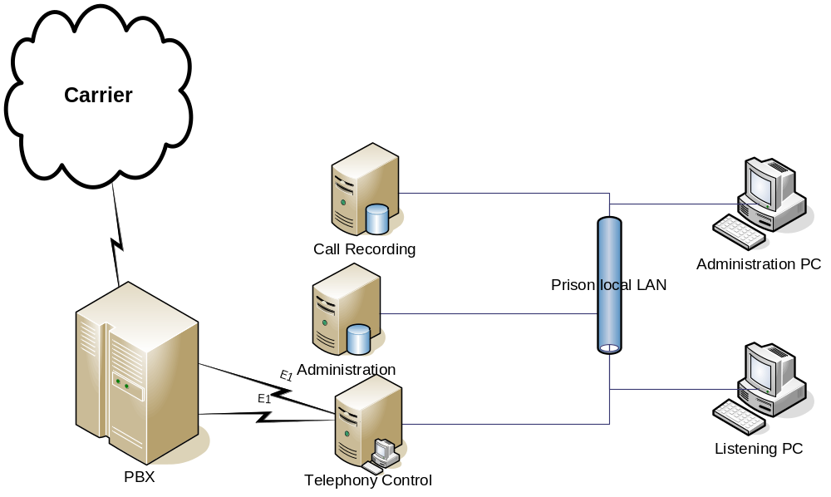

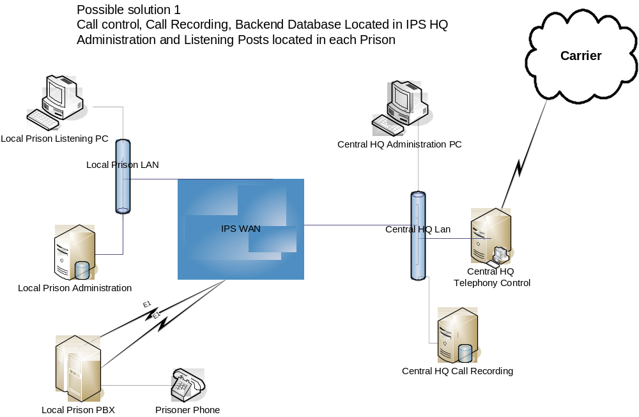

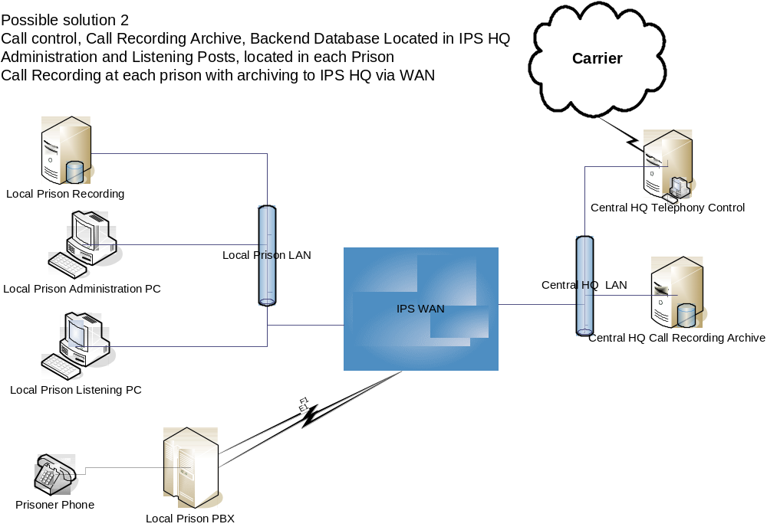

2.0 Other Requirements.

Companies should:

- Detail the provider’s policy on retention and availability of spare parts for the proposed products. Outline the stock levels available to engineers and state whether these stocks are held by the service provider or by another party.
- Provide details of the number of engineering and technical staff engaged in full-time support at the base/s from which the services in question would be provided, these details should be broken down on a site location basis.
- Supply the names and addresses and contact details of two reference customers who, in the last two years have been provided with maintenance and support services similar to that described in this document.
- Due to the critical security nature of the service provided, IPS will require complete commercial confidentiality regarding the design and operation of the system

For evaluation purposes, the Contracting Authority can only consider the information as provided by the Applicant.

6.3 Evaluation Process: Compliant tenders will be initially evaluated by reference to the following completeness of the documentation referred to above.

AWARD CRITERIA

Please address all 4 criteria listed below.

Tenders that fulfill the above qualifying criteria will be evaluated on the basis of the most economically advantageous tender and the extent to which each tender complies with the requirements set out in the Specification Document applying the following award criteria:

- Total Contract Cost (50%)

- Proposed Solution (30%)

- Management information reports and formats offered. (10%)

4. Technical assistance, added value, experience of the Contract Manager and staff nominated to run this contract (10%)

A short list of qualifying service providers may be prepared. These service providers may be invited to an assessment consultation / presentation, which will take place at a time and venue to be advised. The decision to award the contract will be based on the contents of the written proposal and the assessment / presentation, if conducted.

Criteria 1: Total Contract Cost.

This will cover all costs arising under this contract.

Criteria 2:.Proposed Solution

How the solution aligns to IPS requirements. (See 6.2 of this document).

Criteria 3: Management information reports and formats offered.

The recording of management information for financial and regulatory purposes is important. You should state what systems; manual and / or computerised you have in place to meet these requirements. Sample documentation should be submitted e.g. report documents, invoicing / payments documents etc

Criteria 4: Technical assistance, added value, experience of the Contract Manager and staff nominated to run this contract.

How will you assist the IPS in making technical assistance available? What other feature(s) of your business may assist the IPS in the execution of this contract? The satisfactory execution of this contract is reliant on the quality and experience of people engaged to carry out the work. Details are required of the manager and staff who will actually carry out the work. A short C.V. or resume is required for the manager and for all such staff.

Part 7 - General Conditions of Tender.

  - The invitation to tender will give rise to an ongoing national contract for the provision of a telephony management system for non staff in the Irish Prison Service. It is envisaged that all requirements for this service will be procured from this contract during its duration.

  - Late or incomplete tenders shall NOT be considered.

  - The Irish Prison Service does NOT bind itself to accept the lowest or any tender, and reserves to it the power to accept any part of any tender, unless the person tendering expressly stipulates to the contrary at the time of tendering.

  - Financial Arrangements All quotations and payments shall be in Euro only. Payment for any services will be on foot of invoices and made only after delivery and certification. Payment may be made by electronic fund transfer. The Irish Prison Service reserves the right to initiate payment by Purchasing Card at any stage during the life of any contract. Such payment may be introduced on a phased basis.

  - Any variants on the service offered from those initially tendered to the Irish Prison Service shall be demonstrated to the Irish Prison Service prior to any delivery. Deliveries of any such variants in service shall be made only after the consent of the Irish Prison Service is obtained.

  - The Irish Prison Service reserves the right to cancel without notice any contract, should any of the following occur:-

    - The service provider fails to provide a service to the standard demonstrated to the Irish Prison Service prior to the initiation of the contract.

    - The service provider invoices services to the Irish Prison Service at a cost higher than that currently notified.

    - The service provider fails to deliver any service specified within the delivery time specified.

  - In the event of any contract being terminated, the Irish Prison Service reserves the right to review the unsuccessful tenders and engage an alternative service provider. Any such review shall be carried out under the terms of EU Directive 2004/18 and the National Public Procurement guidelines.

  - Any registerable interest involving the candidate and employees of the Irish Prison Service or their relatives must be fully disclosed in the response to this tender competition. The terms ‘registerable interest’ and ‘relative’ shall be interpreted as per section 2 of the Ethics in Public Office Act, 1995.

  - Information supplied to candidates by the Irish Prison Service or its representatives is supplied only for general guidance in the preparation of the proposals. Candidates must satisfy themselves by their own investigations as to the accuracy of such information and no responsibility is accepted for any loss or damage of whatever kind and howsoever caused.

  - All information supplied by the Irish Prison Service or its representative in connection with this invitation to tender shall be regarded as confidential.

  - Candidates should not disclose the fact that they have been invited to tender nor release details of the tender document other than on an “in-confidence” basis to those who have legitimate need to know or whom they need to consult for the purpose of preparing the tender.

  - The Candidate understands and agrees that the Irish Prison Service has the sole right to select the successful Candidate for the award of the contract and to reject any proposal that it judges to be incomplete. Further, the Irish Prison Service is not obliged to award any contract at all as a result of this invitation to tender.

  - The Irish Prison Service will not be liable in respect of any costs incurred by candidates in the preparation of tenders or any associated work effort, including the evaluation of the services offered.

  - Information supplied by the candidates will be contractually binding and treated in confidence, subject to the Irish Prison Services obligations under the Freedom of Information Act 1997. The Irish Prison Service reserves the right to seek clarification or verification of any such information offered by the candidate(s).

Appendix D: Declarations

Please note that it is mandatory to complete and sign these three documents. Failure
to do so shall result in the tender being incomplete and excluded from evaluation.

TENDER

To the Director General of the Irish Prison Service

I/WE, the undersigned (hereinafter styled "The Service provider") hereby engage to provide and deliver at the prisons named in the schedule(s) herein, at the price or prices stated in the schedule(s), supplies of any or all of the articles indicated in the schedule(s) and against which I//WE have inserted prices in respect of which this tender may be accepted, in such quantities and at such times as may be demanded by the Irish Prison Service or an authorised officer acting on his behalf, in accordance with the specifications and conditions of Contract herein during the period from the date of commencement of contract for a period of up to 4 years.

I/WE, the undersigned (hereinafter styled "The Service provider") furthermore agree to be bound by the terms and conditions of the contract as set out in the pages of this document.

Dated this _______________________ day of ________________________ 2009

Signature, in full of Service provider or
of Duly Authorised Agent of Service provider

..................................................................................................................................

Name of Service provider .................................................................................................................................

Postal Address .................................................................................................................................

............................................................................................................................................

Telephone............................................................. Mobile...................................................

Fax.................................................

DECLARATION

SI 329 of 2006 European Communities (Award of Public Authorities’ Contracts) Regulations 2006.

The tender is subject to the EU Open Procedures as described in the European Parliament and the Council Directive 2004/18/EC on the co-ordination of procedures or the award of public works, public supply & public service contracts , and SI 329 of 2006 European Communities (Award of Public Authorities’ Contracts) Regulations 2006.

THIS DECLARATION, DULY COMPLETED, MUST BE SUBMITTED BY ALL SERVICE PROVIDERS. FAILURE TO COMPLETE THIS DECLARATION FULLY AND SUBMIT SAME WILL EXCLUDE YOUR TENDER FROM FURTHER CONSIDERATON.

Name of Tenderer:

Address:

Country: ___________________________________________________________

THIS FORM MUST BE COMPLETED AND SIGNED BY A DULY AUTHORISED OFFICER OF THE TENDERER’S ORGANISATION

DECLARATION

I certify that I or my organisation is not subject to the exclusions as set out in SI 329 of 2006 European Communities (Award of Public Authorities’ Contracts) Regulations 2006 to the best of my knowledge and belief.

I understand that the provision of inaccurate or misleading information in this declaration may lead to my organisation being excluded from participation in this tender.

SIGNATURE DATE:

NAME TEL:

POSITION FAX:

Email: ______________________Company Registration No: ___________________

V.A.T. Number: ___________________

THIS DECLARATION, DULY COMPLETED, MUST BE SUBMITTED BY ALL CANDIDATES
To:
The Manager,
Central Procurement Unit,
Irish Prison Service HQ
IDA Business Park
Ballinalee Road
Longford

I / We the undersigned (the Candidate) do offer in accordance with the invitation to tender, to provide and deliver, at the premises detailed in this document any or all of the supplies or services specified in the schedule at the prices stated therein and subject in all respects to the attached conditions of contract set out in the pre-qualifying questionnaire to this tender. In this certificate the word ‘person’ includes any persons and any body or association corporate or otherwise and the words ‘any contract or arrangement’ includes any such transaction formal or informal and whether legally binding or not.

  - Tenders shall hold good for three calendar months from the latest date on which the tender is due to reach the IPS.

  - Any modification that a person tendering may wish to propose in the Conditions of Contract or otherwise, must only be made by means of a letter enclosed with the tender.

  - I accept that it will be a condition for the award of a contact that I must submit and maintain for the duration of the contract with the IPS, a current tax clearance certificate from the Revenue Commissioners.

  - The acceptance of any tender does not, in any way, bind the IPS to place any order with any service provider.

  - I confirm the following replies to the questions below to be true and accurate:

Has the candidate (including all directors and partners):

5.1 | Been convicted of an offence involving –  (a) participation in a prescribed criminal organisation,  (b) corruption, or  (c) fraud, or  (d) money laundering. | Yes [ ] No [ ]
5.2 | Been or is currently subject to a bankruptcy or insolvency procedure or process of a kind specified in Regulation 53, paragraph (5) of S.I. 329/2006 | Yes [ ] No [ ]
5.3 | Been found guilty of professional misconduct by a competent authority that is authorised by law to hear and determine allegations of professional misconduct against persons that include the operator | Yes [ ] No [ ]
5.4 | Committed grave professional misconduct provable by means that the authority can demonstrate | Yes [ ] No [ ]
5.5 | Failed to fulfill any obligation to pay social security contribution as required by a law of the country or territory –  (i) where the person ordinarily resides or carries on business, or  (ii) where the authority is established | Yes [ ] No [ ]
5.6 | Failed to fulfill any obligation to pay a tax or levy imposed by or under a law of the country or territory –  (i) where the person ordinarily resides or carries on business, or  (ii) where the authority is established | Yes [ ] No [ ]
5.7 | Provided a statement or information to the authority or other contracting authority knowing it to be false of misleading, or has it failed to provide to the authority or another such authority a statement or information that is reasonably required by the authority for the purpose of awarding the public contract concerned. | Yes [ ] No [ ]

  - We certify that this is a bona fide tender and that we have not fixed or adjusted the amount of the tender by or under or in accordance with any contract or arrangement with any other person. We also certify that we have not done and we undertake that we will not do at any time before the hour and date specified for the return of this tender any of the following acts:

  - communicating to a person other than the person calling for those tenders the amount or approximate amount of the proposed tender except where the disclosure in confidence of the approximate amount of the tender was necessary to obtain insurance premium quotations required for the preparation of the tender;

  - entering into any contract or arrangement with any other person that he shall refrain from tendering or as to the amount of any tender to be submitted;

  - offering or paying or giving or agreeing to pay or give any sum of money or valuable consideration directly or indirectly to any person for doing or having done or causing or having caused to be done in relation to any other tender or proposed tender for the said work any act or thing of the sort described above.

- I further certify that the principles described in paragraph 1 above have been or will be brought to the attention of all sub-service providers service providers and associate companies providing services or materials connected with the tender and any contract entered into with the sub-service providers service providers or associated companies will be made by all parties on the basis of compliance with the above principles.

- I confirm that any breach of the conditions of this collusive tendering certificate will inevitably lead to the rescission of the contract by the IPS.

- I certify that the information provided above is accurate and complete to the best of my knowledge and belief. I understand that the provision of inaccurate or misleading information in this declaration may lead to my organization being removed from the tender competition.

Dated this: ___________________________day of ________________2009

Signature:________________________ Name (capitals)________________

In the capacity of ___________________________________________________
(State official position e.g. Director, Manager etc.)
being a person duly authorised to sign tenders on behalf of:

Name of candidate: ________________________________________________

Part 8 - Conditions of Contract

TERMS & CONDITIONS OF CONTRACT

1. DEFINITIONS:

1.1 All references to “the IPS” shall be construed as meaning Irish Prison Service.

1.2 All reference to “the service provider” shall be deemed:

1.2.1 In the case of a single service provider, to include executors, administrators and
permitted assignees of the service provider.

1.2.2 In the case of several service provider(s) to include jointly and severally the
Partnership firm (if any) and each of the service providers and their respective
executors, administrators and permitted assignees; or

1.2.3 In the case of a company, to include its successors and permitted assignees.

1.2.4 All references herein to “articles” shall be construed as meaning the goods and / or
services to be supplied under the contract.

  - All reference to “Contract” means the contract for the supply of works, services or supplies usually in the form of a purchase order, made between the IPS and the service provider as a result of the acceptance, by the IPS, of the service providers tender.

2. GENERAL CONDITIONS - These Conditions shall be governed by and construed in accordance with Irish law and the Service provider hereby irrevocably submits to the jurisdiction of the Irish Courts. The submission to such jurisdiction shall not (and shall not be construed so as to) limit the right of the Irish Prison Service to take proceedings against the service provider in any other court of competent jurisdiction, nor shall the taking of proceeding in any one or more jurisdictions preclude the taking of proceedings in any other jurisdiction, whether concurrently or not.

3. ACCEPTANCE OF TERMS BY THE SERVICE PROVIDER – These conditions of contract shall prevail over any terms offered or prepared by the service provider.

4. CONFORMITY TO SPECIFICATION - The services provided shall conform to the specifications of the IPS and the prices quoted in the tender shall be for services conforming in every respect to the specifications of the IPS and not to the service providers own specifications.

5. SALE OF GOODS AND SUPPLY OF SERVICES ACT 1980 – Any conditions, warranties or undertakings arising or implied by statute (including for the avoidance of doubt, arising under the Sale of Goods Act and Supply of Services Act 1980) in favour of the IPS in respect of the sale of goods and supply of services shall be deemed to be included in these conditions of contract.

6. ORDERS - Orders for services will be in writing from the Manager of the Central Procurement Unit, or an officer authorised to act on behalf of the Manager.

7. DELIVERIES – The articles to be supplied under the Contract shall be the respective qualities and descriptions stated in the Tender, and unless otherwise specified, shall be of the best quality of the particular article described, and equal to in all respects to the standard patterns, specifications, drawings or samples, (herein called “the standard”) of such articles respectively. Articles shall be delivered by the service provider, to the IPS at the respective times and places of delivery named in the Tender within the respective periods and schedules for delivery stated therein.

8. DEFAULT - Services must be provided at the day and time, and in the location, as specified by the Manager, Central Procurement Unit, Irish Prison Service or an officer authorised to act on behalf of the Manager. If the service provider shall fail to provide the services demanded at the specified times or places or to provide suitable services in lieu of those rejected, the IPS or an authorised officer acting on his behalf may purchase services to replace those deficient, and the service provider shall defray any excess between the Contract price and the price paid, together with all expenses incurred in connection with such purchase in default.
9. PAYMENT OF ACCOUNTS - The service provider shall submit invoices in conformity with Section 17 of the Vat Act 1972 on a monthly basis to the Manager, Central Procurement Unit, unless otherwise specified by the IPS. Payment will be made in accordance with the Prompt Payment of Accounts Act, 1997.

10. RECOVERY OF SUMS DUE - Whenever under the Contract any sum of money shall be recoverable from or payable by the service provider, the same may be deducted from any sum then due or which at any time thereafter may become due to the service provider under this or any other Contract with the IPS without prejudice to the right to recover same as a civil debt.

11. EFFECT OF CUSTOMS OR OTHER DUES ON CONTRACT PRICE - (a) If subsequent to the date of the Tender any customs or excise duty or import licence fee affecting the material or any part of the material is increased, decreased, imposed or abolished, or any alteration is made in the practice of assessing the value of goods for the purposes of customs duty and the amount of duty payable on the material or any part of the material is thereby increased or decreased, the amount to which the service provider shall be entitled under the Contract shall be increased or decreased as case may require, by a sum equal to the difference between the amount of duty or import licence fee, which would have been payable at the date of the Tender and the amount actually paid by the service provider on the material delivered by him under the Contract.
(b) If subsequent to the date of the Tender, the rates of Value Added Tax payable by the service provider on the moneys received from the IPS under the Contract are increased, or decreased, the amount to which the service provider shall be entitled under the Contract shall be increased, or decreased, so that the amount, less Value added Tax at the revised rates, equals the amount less Value Added Tax at the rates obtaining at the date of the Tender.
(c) The service provider shall, whenever so required by the IPS, produce for inspection all invoices, customs entries, receipts for import licence fees, and other documents in his possession or under his control which may, in the opinion of the IPS, be necessary to enable the amount of duty, import licence fee, cartage, or rail charges, etc. if any, paid on the materials or any part thereof to be determined.

12. HEALTH SAFETY & WELFARE – The service provider shall ensure that all goods or materials supplied to the IPS as part of any contract shall comply with all current EU and Irish Health and Safety Standards. The service provider shall ensure that any member of staff operating within the confines of the IPS premises shall adhere to all current EU and Irish Health and Safety Standards in addition to the IPS’s safety standards and statements.

13. DAMAGE – The service provider shall make good all damage that may be caused by an act or default of the service provider, the service provider’s agents or servants, to any property of the IPS. The IPS shall maintain the option to have the damage otherwise made good and to charge the service provider with the expense.

14. INSURANCE – (a) The service provider shall at all times insure and keep itself insured with a reputable insurance company, approved by the Purchaser, against all insurable liability under this Contract in respect of the supplies and, without prejudice to the generality of the foregoing, in respect of all claims by third parties for death, injuries, or damage to property, and against all actions, suits, claims, demands, costs and expenses whatsoever, by reason of, or arising out of any claim by any of the service provider’s employees, workmen or servants, in respect of any accident, death, injury or damage sustained in connection with or arising out of the execution of this Contract, or any of the matters connected therewith, whether such claims or proceedings be brought or costs or expenses incurred under or by virtue of any Workmen’s Compensation Act 1934, as amended, or other statute or at common law, or otherwise howsoever.

For each relevant category the service provider shall, unless otherwise agreed in writing between the parties, maintain the following minimum insurances:

(b) public liability insurance with a minimum limit of indemnity of €6.5m;

(c) employer’s liability insurance in relation to employees of the service provider servicing or installing supplies on the Purchaser’s property. The limit of indemnity under this policy should be €13m for any one occurrence;

(e) In the event of supplies being supplied and then installed by the service provider, evidence of all risks insurance, in the joint names of the IPS and the service provider, on the supplies should be presented until such time as the IPS accepts responsibility following the installation.

(g) The public liability and employer’s liability insurance policies referred to in sub-conditions (b) and (c) above should extend to provide an indemnity to the Purchaser.

(h) The Service provider shall provide all faculties, assistance and advice required by the Purchaser or the Purchaser’s agents for the purpose of contesting or dealing with any action, claim or matter arising out of the Service provider’s performance of this Contract.

(i) The name on the insurance certificate must be the legal name of the Service provider.

(j) The said insurance policy or policies shall be furnished, duly completed, to the Purchaser prior to the commencement of this Contract, maintained for the duration of this Contract and up-to-date copies forwarded to the Purchaser each year. All policies presented shall contain an Irish law jurisdiction clause.

15. ENVIRONMENTAL POLICY – The service provider shall comply with air pollution, water pollution and other environmental regulations in the performance of this contract, and, to that extent they shall comply with the provisions of all current EU and Irish legislation in this respect.

16. CORRUPT GIFTS TO PERSONS IN THE GOVERNMENT SERVICE - The Service provider shall not offer to give or agree to give to any person in the service of the State any gift or consideration of any kind as an inducement or reward in relation to the obtaining or execution of this or any other Contract for or with the Government or any IPS or Department thereof.
Any breach of this condition by the service provider or by anyone employed by him or acting on his behalf (whether with or without the knowledge of the service provider) or the commission of any offence by the service provider or by anyone employed by him or acting on his behalf under the Prevention of Corruptions Act, 1889 to 1916 and / or the Prevention of Corruption (Amendment) Act 2001, in relation to this or any other Contract for or with the Government or any IPS or Department thereof shall render the service provider liable to the cancellation of this Contract and any other existing Contracts with the IPS and shall entitle the IPS to recover from the service provider the amount of any loss resulting from such cancellation.
Any dispute or difference of opinion arising in respect of either the interpretation, effect or application of this condition or of the amount of damages recoverable by the IPS from the service provider as a result of cancellation hereunder, shall be decided by the IPS for Finance in such manner and on such evidence or information as he may think fit and his decision shall be final.

17. FAIR WAGES - The service provider shall pay rates of wages and observe hours of labour not less favourable than those commonly recognised by employers and trade societies (or, in the absence of such recognised wages and hours, those which in practice prevail amongst good employers) in the trade in the district where the work is carried out. Where there are no such wages and hours recognised or prevailing in the district those recognised and prevailing in the nearest district in which the general industrial circumstances are similar shall be adopted.
Further, the conditions of employment generally accepted in the district in the trade concerned shall be taken into account in considering how far the terms of this Clause are being observed, and for this purpose regard shall also be had to the conditions of employment generally in the Contracting firm.

18. SUB-LETTING: The Service provider shall be prohibited from transferring or assigning, directly or indirectly, to any person or persons whatever any portion of this Contract without the written permission of the IPS.

19. DISABILITY - A Minister or Minister of State shall not be admitted to any share or part of this Contract or to any benefit therefrom.

20. TERMINATION OF CONTRACT - (a) The IPS shall have power to terminate this Contract forthwith in the event of the service provider failing to comply with any of the conditions of Contract and power to recover from the service provider any loss resulting from such termination and in addition shall have power to terminate the Contract at any time by giving twenty-one days notice to the service provider to that effect.
(b) In addition the Contract may be terminated by the service provider at any time on ninety days notice to that effect being given in writing to the IPS.
(c) The IPS shall have power to terminate or transfer any contract, or portion of a contract, at any time by giving twenty-one days notice to the service provider to that effect.
(d) The IPS may at any time forthwith terminate this Contract if the service provider shall become subject to the Bankruptcy laws or seek or take the protection of the Court or make any arrangement or composition with his creditors or suffer any execution on his premises or, in the case of a company, enter into liquidation whether compulsory or voluntary.

(e) If the service provider neglects or refuses to abide by the terms and conditions of any agreed guarantee or warranty condition, the IPS shall be at liberty to terminate this Contract forthwith and to recover from the service provider any loss sustained by reason of such termination and also (whether Contract is terminated or not) any loss sustained by reason of such breach.

21. APPEAL LIMITED - Should any question or questions arise as to the interpretation of this Contract, or as to the execution of any order or work arising out of the same such question or questions shall be settled by the award of the IPS subject to the right of appeal by the service provider to the IPS for Finance whose decision in such case shall be final.

22. ACCEPTANCE OF PART OF TENDER - Where part of a tender is accepted by the IPS, the conditions of contract and specifications shall apply to such part.

23. Variation of Subject Matter of Contract - The IPS, or an officer authorised to operate on his behalf, shall have the capacity to vary the subject matter of this tender subject to the contract in writing of the contracted party. Approval as to the terms and conditions of the variation must be approved in writing in advance by the Director of Finance, Irish Prison Service before any such variations become legally binding.

24. COMPLIANCE WITH TAXATION REQUIREMENTS -
(a) As contracts are awarded on the basis of the production of a valid clearance certificate. Any failure on the part of the service provider in relation to itself, or in relation to any sub-service providers which it has engaged for the purposes of this contract, to produce a current tax clearance certificate from the Revenue Commissioners will result in the termination of the contract.
(b) The Service provider shall inform the Contracting Authority in writing, within twenty one days, of any changes in relation to its compliance, or the compliance of any sub-service providers which it has engaged for the purposes of this contract, with the taxation requirements of the contract.
(c) The service provider must ensure that a current tax clearance certificate has been lodged in relation to itself, or in relation to any sub-service providers which it has engaged for the purposes of this contract, with the contracting authority, as payments in respect of supplies will not be made until such time as a current tax clearance certificate has been lodged. The Irish Prison Service accepts no liability for any loss, damages, or otherwise, sustained by the service provider as a result of a failure by the service provider to lodge a current tax clearance certificate.
(d) Continuing failure by the service provider to produce a current tax clearance certificate in relation to itself, or in relation to any sub-service providers which it has engaged for the purposes of this contract, may result in the termination of the contract.

25. COMPLIANCE WITH SECURITY REQUIREMENTS -
(a) The service provider must provide such personal information, as deemed necessary by the IPS, in respect of directors, employees and sub-service providers which it proposes to engage for the purposes of the tender for security clearance reasons. Failure to provide such information may result in the termination of the contract.
(b) The service provider shall ensure that the Manager, Central Procurement Unit, Irish Prison Service is notified in writing within 21 days of any changes to directors, employees and sub-service providers engaged for the purposes of the contract. Failure to provide such information may result in the termination of the contract.

(c) The Irish Prison Service reserves the right to amend or modify the level of information required for security clearance over the course of the contract.

26. PATENTS, INFORMATION AND COPYRIGHT –
(a) It shall be a condition of the Contract that, except to the extent that the goods or
services incorporate designs furnished by the service provider, that nothing done
by the service provider in the provision of the goods or services shall infringe any
patent, trade mark, registered design, copyright or other right in the nature of
intellectual property of any third party and the service provider shall indemnify the Irish
Prison Service and the State against all actions, claims, demands, costs and
expenses which the Irish Prison Service or the State may suffer or incur as a result of
or in connection with any breach of the Condition.

(b) all rights (including ownership and copyright) in any reports, documents, specifications, instructions, plans, drawings, patents, models, design whether in writing or on magnetic or other media:

(c) furnished to or made available to the service provider by the Irish Prison Service are hereby assigned to and shall vest in the State absolutely.

(d) prepared by or for the service provider for use, or intended use, in relation to the performance of the Contract are hereby assigned to and shall vest in the State absolutely, and (without prejudice to Sub condition 26(b)) the service provider shall not and shall procure that his servants and agents do not (except to the extent necessary for the implementation of the Contract) without the prior written consent of the Irish Prison Service use or disclose any such reports, documents, specifications, instructions, plans, drawings, patents, models, designs or other material as aforesaid or any other information (whether or not relevant to the Contract) which the Service provider may obtain pursuant to or by reason of the Contract, except information which is in the public domain otherwise than by reason of this provision, and in particular (but without prejudice to the generality of the foregoing) the service provider shall not refer to the Irish Prison Service or the Contract in any advertisement without the Irish Prison Services prior written consent.

(e) The provisions of this Condition shall apply during the continuance of this Contract and after its termination howsoever arising.

27. CONFIDENTIALITY-The successful service provider may have access to documentation
including information regarding Irish Prison Service operational policy, procedures
and personnel.

The service provider will be required to sign an undertaking and to ensure that all personnel with access to Irish Prison Service data sign undertakings for the purposes of compliance with the Official Secrets Act 1963 and the Data Protection Act 1988.

Service providers must confirm that they will provide the required undertakings.

28. INSPECTION – The acceptance by the IPS of all articles shall be subject to their examination by the IPS as soon as practicable after delivery. The IPS may reject any articles, which are found to be inferior or defective in quality or to differ from standard. The service provider shall remove all rejected articles at the service providers own expense within 10 days of being required by notice to do so and no allowance shall be made to the service provider in respect of any articles so rejected. Such rejected articles shall not be considered as having been delivered under the Contract. Any rejected articles not removed within the prescribed time may be re-consigned to the service provider, who shall repay to the IPS any expense thereby incurred or occasioned.

29. LIABILITY FOR QUALITY - The service provider shall be liable for replacement of any article which is defective and required to maintain the quality of service. Such articles shall be replaced by the service provider within 7 days of receipt by him of written notification. If the service provider neglects or refuses so to remove and replace such articles the IPS shall be at liberty to terminate this Contract forthwith and to recover from the service provider any loss sustained by reason of such termination, irrespective of whether Contract is terminated or not.

30. SOFTWARE REQUIREMENTS – Any service provider supplying goods or services under a contract shall warrant that any software supplied will function in accordance with its functional specifications.

31. SECURITY CLEARANCE - The tenderer shall supply the awarding authority, as part of the tender documentation, with the name, address, date of birth and Personal Public Service Number: for all Directors or owners together with all members of staff they propose to employ, including subcontracted party, for the purpose of full filling the contract. Failure to provide this information may result in the tender being discounted from the competition. If for any reason any Director/Owner, employee or subcontracted party of the company fails to obtain the necessary clearance the tender may be discounted from the competition. This information must also be provided prior to the employment of any additional staff, for the purposes of the contract, during the course of the contract. In the event of a failure to comply with this requirement the IPS shall be at liberty to terminate this Contract forthwith and to recover from the Service provider any loss sustained by reason of such termination and also (whether Contract is terminated or not) any loss sustained by reason of such breach.

32. SERVICE PROVIDER’S EMPLOYEES AND REPRESENTATIVES – (a) The service provider will take all steps reasonably required by the Irish Prison Service, to prevent unauthorised persons being admitted to the Site. If the Irish Prison Service gives the service provider notice that any person is not to be admitted to or is to be removed from the Site or is not to become involved in or is to be removed from involvement in the Contract, the service provider will take appropriate steps to comply with such notice.

(b) The decision of the Irish Prison Service as to whether any person is to be admitted to or is to be removed from the Site or is not to become involved in or is to be removed from involvement in the Contract will be final and conclusive.

33. PUBLICITY - (a) No announcement or information concerning the Award of this
Contract, its contents or the provision of the services shall be made or released, or be authorised to be made or released by either of the parties without the prior written consent of the other, except that either party may make such announcement or release such information (or authorise the making or releasing of same) in so far as required to do so by law.

(b) Both parties shall take all reasonable steps to ensure the observance of the provisions of Sub-condition 33(a) by their employees, agents, representatives or sub-service providers.

34. NOTICES - Any notice given under or pursuant to the Contract may be sent by hand or by post or by registered post or by the recorded delivery service or transmitted by telex, telemessage, facsimile transmission or other means of telecommunication resulting in the receipt of a written communication in permanent form and if so sent or transmitted to the address of the party shown on the Purchase Order, or to such other address as the party may by notice to the other have substituted therefor, will be deemed effectively given on the day when in the ordinary course of the means of transmission it would first be received by the addressee in normal business hours.

35. WAIVER - (a) The failure of the Irish Prison Service to insist upon strict performance of any terms of the Contract, or the failure of the Irish Prison Service to exercise any right or remedy to which it is entitled in terms of or in respect of the Contract or any part or term thereof, shall not prejudice or restrict any right of the Irish Prison Service and shall not constitute a waiver of any obligation incumbent upon, or breach of Contract or default by the Service provider.

(b) No waiver of any term of the Contract, or any breach of Contract or default by the Irish Prison Service shall be effective unless made in a written notice which expressly states that it constitutes a waiver of the said term, breach or default.

(c ) No waiver of any right, remedy or obligation given by the Irish Prison Service in accordance with Sub condition 35(b) hereof shall operate as a waiver of any other term of the Contract, breach of Contract, default, right, remedy or obligation other than that to which its terms expressly refer.

36. SEVERABILITY - (a) If any provision of the Contract is declared by any judicial or other competent authority to be invalid, void, illegal, or otherwise unenforceable then such provision shall be severed and the remainder of the provisions hereof shall continue in full force and effect as if the Contract had been executed with the invalid provision eliminated unless, in the Irish Prison Services opinion, the effect of such declaration is to defeat the original intentions of the parties in which event the Irish Prison Service and the service provider shall immediately commence good faith negotiations to remedy such invalidity. In the event that the said negotiations have not been concluded within twenty eight days of the Irish Prison Service giving the service provider written notice that such negotiations are required, the Irish Prison Service may terminate the Contract by written notice with immediate effect to the service provider

37. INDUSTRIAL ACTION - (a) In the event of industrial action by the service provider's employees it remains the service provider's responsibility to fully and timeously implement all duties, functions, liabilities, obligations and responsibilities incumbent upon it in terms of the Contract.

(b) The service provider shall inform the Irish Prison Service of impending or actual disputes, which may affect the service provider’s ability to provide the services immediately the service provider becomes aware of the same.

(c) In the event of industrial disputes by staff employed directly by the Irish Prison Service or other service provider affecting the services provided by the service provider, the service provider shall co-operate with the Irish Prison Service in order to ensure the continued provision of the services as far as reasonably practicable during the continuance of any such industrial dispute.

(d) If the standard of service provided is substantially affected by any industrial action or industrial dispute of the kind referred to in Sub condition 36(a) or 36(b) above, payment for the services provided during the continuance of any such industrial action or industrial dispute will be agreed between the service provider and the Irish Prison Service.

38. SERVICE PROVIDER'S STATUS - (a) In carrying out the supply of services within this Contract, the service provider shall be acting as principal and not as the agent of the Irish Prison Service.

Accordingly:

(1) the service provider shall not (and shall procure that his agents and servants do not) say or do anything that might lead any other person to believe that the service provider is acting as the agent of the Irish Prison Service, and

(2) nothing in the Contract shall impose any liability on the Irish Prison Service in respect of any liability incurred by the service provider to any other person but this shall not be taken to exclude or limit any liability of the Irish Prison Service to the service provider that may arise by virtue of either a breach of the Contract or any negligence on the part of the Irish Prison Service, his staff or agents.

39. CONFLICT OF INTEREST - (a) The service provider shall take all measures necessary to ensure that no conflict of interest exists or arises relating to the service provider or any Staff that could in any way adversely affect the performance of the Contract. The service provider shall promptly notify the Authority in writing if he knows or becomes aware of any conflict of interest or any circumstances that could give rise to a conflict of interest

(b) It the Irish Prison Service becomes aware of any conflict of interest or any circumstances that could give rise to a conflict of interest, the Irish Prison Service shall have the right, after taking into account all representations made by the Service provider: (a) to allow such period as may be specified by the Irish Prison Service, during which period the service provider shall have the opportunity to take any measures necessary to ensure that the conflict of interest, or the cause of the potential conflict of interest, is removed; or (b) to terminate the Contract, if in the opinion of the Irish Prison Service, there is a conflict of interest that cannot be removed.

(c) Where the Irish Prison Service has exercised the option under Sub condition 38 (a) and the service provider fails to demonstrate to the satisfaction of the Irish Prison Service that the conflict of interest, or cause of the potential conflict, has been removed, the Authority shall have the right to terminate the Contract.

40. AUDIT -
The service provider will keep and maintain until 3 years after the Contract has been completed records to the satisfaction of the Irish Prison Service of all expenditures which are reimbursable by the Irish Prison Service and of the hours worked and costs incurred in connection with any employees of the service provider paid for by the Irish Prison Service Purchaser on a time charge basis. The service provider will on request afford the Irish Prison Service or its representatives such access to those records as may be required by the Irish Prison Service in connection with the Contract.

41. FREEDOM OF INFORMATION ACT – The IPS will endeavour to hold confidential
any information provided by service providers, subject to the IPS’s obligations under
the law. Service providers should note that the IPS might, under this act, be under
an obligation in certain circumstances to divulge or grant access to information and
records which are contained in proposals or which are otherwise acquired in the
course of the award procedure. The IPS will in all instances be bound by the findings
of the Information Commissioner with regard to any requests under the Act.

42. FORCE MAJEURE

(a) For the purposes of this Contract, the expression "Force Majeure" shall mean any governmental regulations, fire, flood, or any disaster affecting or delaying the performance by a party of its obligations. Any act, event, omission, happening or non-happening will only be considered Force Majeure if it is not attributable to the wilful act, neglect or failure to take reasonable precautions of the party seeking to rely on it, or of that party’s agents or employees.
(b) Neither party shall in any circumstances be liable to the other for any loss of any kind whatsoever directly or indirectly caused or incurred by the other party by reason of any failure or delay in the performance of its obligations hereunder which is due to Force Majeure. Notwithstanding the foregoing, each party shall use all reasonable endeavors to continue to perform, or resume performance of, such obligations hereunder for the duration of such Force Majeure event.

(c) If either of the parties shall become aware of circumstances of Force Majeure which give rise to or which are likely to give rise to any such failure or delay on its part it shall forthwith notify the other by the most expeditious method then available and shall inform the other of the period which it is estimated that such failure or delay shall continue.
(d) In the event that the Force Majeure event is continuing for a period at least one (1) month, the other party shall have the right to terminate this Contract upon seven (7) days notice.
(e) It is expressly agreed that any failure by the Service provider to perform, or any delay by the Service provider in performing its obligations under this Contract, which results from any failure or delay in the performance of its obligations by any person, firm or company with which the Service provider has a contract, supply arrangement or sub-contract or otherwise shall be regarded as a failure or delay due to Force Majeure only in the event that such person, firm or company shall itself be prevented from or delayed in complying with its obligations under such contract, supply arrangement or sub-contract or otherwise as a result of circumstances of Force Majeure.
(f) For the avoidance of doubt it is hereby expressly declared that the only events which shall afford relief from liability for failure or delay shall be events falling within the definition of Force Majeure set out in sub-clause 1 above, and therefore exclude other events such as strikes, lock-outs or industrial disputes of the Service provider.

Candidate Questionnaire –
PART A – GENERAL INFORMATION
A1 Full name, address and website of the potential provider:

Company Name
Address
Town/City
Postcode
Country
Website

A2 Name, position, telephone number and e-mail address of main contact for this project.

Name
Position
Telephone Number
Fax Number
E-mail

A3 Current legal status of the potential provider (e.g. partnership, private limited company, etc.)

Please
(tick one box)
Sole Trader
Partnership
Public Limited Company
Private Limited Company
Other (please state)

A4 Date and place of formation of the potential provider, registration under the Companies Act, please provide copies of Certificate of Incorporation and any changes of name, registered office and principal place of business.

Date of formation
Place of formation
Date of registration
Registration number
Registered Office
Brief Description of the potential provider’s primary business and main products and services.
Brief history of the potential provider’s organisation, no more than 400 words, including details of any parent and associated companies and any changes of ownership over the last 5 years including details of significant pending developments, changes in financial structure or ownership, prospective take-over bids, buy-outs and closures etc which are currently in the public domain.

A6 Please provide a one-page chart illustrating the ownership structure of the potential Provider including relations to any parent or other group or holding companies.

Ownership structure enclosed (please )

A7 Registration with professional body.

Where applicable, is the potential provider registered with the appropriate trade or professional register(s) in the EU member state where it is established (as set out in Annex IX B of Directive 2004/18/EC) under the conditions laid down by that member state*).

Evidence of registration with appropriate professional/trade body
Either insert required details or state ‘None’

PART B – FINANCIAL STANDING
B1 Name and address of principal banker together with banker’s reference.

Bank Name
Address
Town/City
Postcode

Banker’s reference enclosed (please )

B2 Accounts information — please provide a copy of the full report and audited accounts for the last 3 financial years. If the accounts you are submitting are for a year ended more than 10 months ago please also enclose the latest set of management accounts.

Please  or state ‘N/A’
Profit and Loss Accounts
Balance Sheet
Full accompanying notes
Director’s/Managing Partner’s Report (if available)
Auditor’s Report

B3 Please supply the following information from the last [3] financial years:

 | Amount  (€K)  2007/8 | Amount  (€K)  2006/7 | Amount  (€K)  2005/6
Overall turnover for last 3 years
Turnover in relevant services
Operating Profit
Profit in relevant services
Current Assets
Current Liabilities
Long Term Liabilities
Net Assets
Numbers of Staff working in relevant services

If the information you are submitting is for a financial year-end more than 10 months ago, please submit the latest available information or a statement signed by the Finance Director detailing any major changes in the current financial position since the date of the latest information provided.

Potential providers who do not have three years of audited accounts should provide whatever audited accounts they may have. Newly formed potential providers should provide a statement of the potential provider’s turnover, profit & loss account and cash flow for the most recent year of trading and / or a statement of the potential provider’s cash flow forecast for the current year and a letter from the potential provider’s bank outlining the current cash and credit position.

B4 Insurance - Please provide evidence of the employers' liability, public liability insurance, product liability and professional liability or indemnity insurance held by the potential provider. The evidence should include the name of the insurers, policy numbers, expiry dates and limits for any one incident and annual aggregate caps and the excesses under the policies.

Details | Type of Insurance
Details | PII | Product Liability | Employer Liability | Public Liability
Name and address of insurer
Policy No
Expiry Date
Limit of indemnity (per occurrence and aggregate)
Excess ( if any)

B5 Please provide a statement of any material pending or threatened litigation or other legal proceedings (where not otherwise reported) where the claim is of a value in excess of [€60,000].

Disclosure of legal proceedings (500 words or fewer)
Either insert required details or state ‘None’

PART C – CONTRACTUAL MATTERS
C1 Have any of the following circumstances occurred on any contract involving your company during the last 3 years:

Yes/No
Financial deduction or liquidated damages imposed?

Contract terminated or your employment determined (terminated)?

Contract not renewed for failure to perform to the terms of the contract?

Withdrawal from a contract prematurely?

Outstanding claims or litigation against your company?

If Yes, please provide full details on a separate sheet.

PART D – EXPERIENCE
D1 Please provide details of project requirements similar to those to be provided (as set out in Section 1.4) that the potential provider has delivered in the past two years. Please include dates or period on which the requirements were provided, the contract values and the details of the recipient of the requirements.

Provision of similar services (500 words or fewer)
Either insert required details or state ‘None’
- Dates or period on which the requirements were provided.
- The Contract values.
- The details of the recipient of the requirements.

PART E – REFERENCES
E1 Please provide details of at least 3 current contracts i.e. commencement in the last 3 years (preferably in large public environments). For each reference, specify the following;

Client Name/Address | Contact Name/Tel/Email | Contract Start | Contract Period (Months) | Overall Contract Value | Contract Description

I certify that the information supplied is accurate to the best of my knowledge and that I accept the conditions and undertakings in the form.

To be signed by an authorised representative.

Signed: ................................................................... Position: ..................................................

Name in block letters: …………………………………..

Dated:

CHECK
N.B.

BEFORE LODGING YOUR TENDER FORM(S) PLEASE CHECK THAT ALL RELEVANT PARTS ARE COMPLETED AND SIGNED OFF AS REQUIRED.

Tenders should be lodged with The Manager, Finance Directorate – CPU, Irish Prison Service HQ, IDA Business Park, Ballinalee Road, Longford not later than 4:00 pm on Thursday, 14th May 2009.

